HSPICE Homework #2

**Hw2.1**

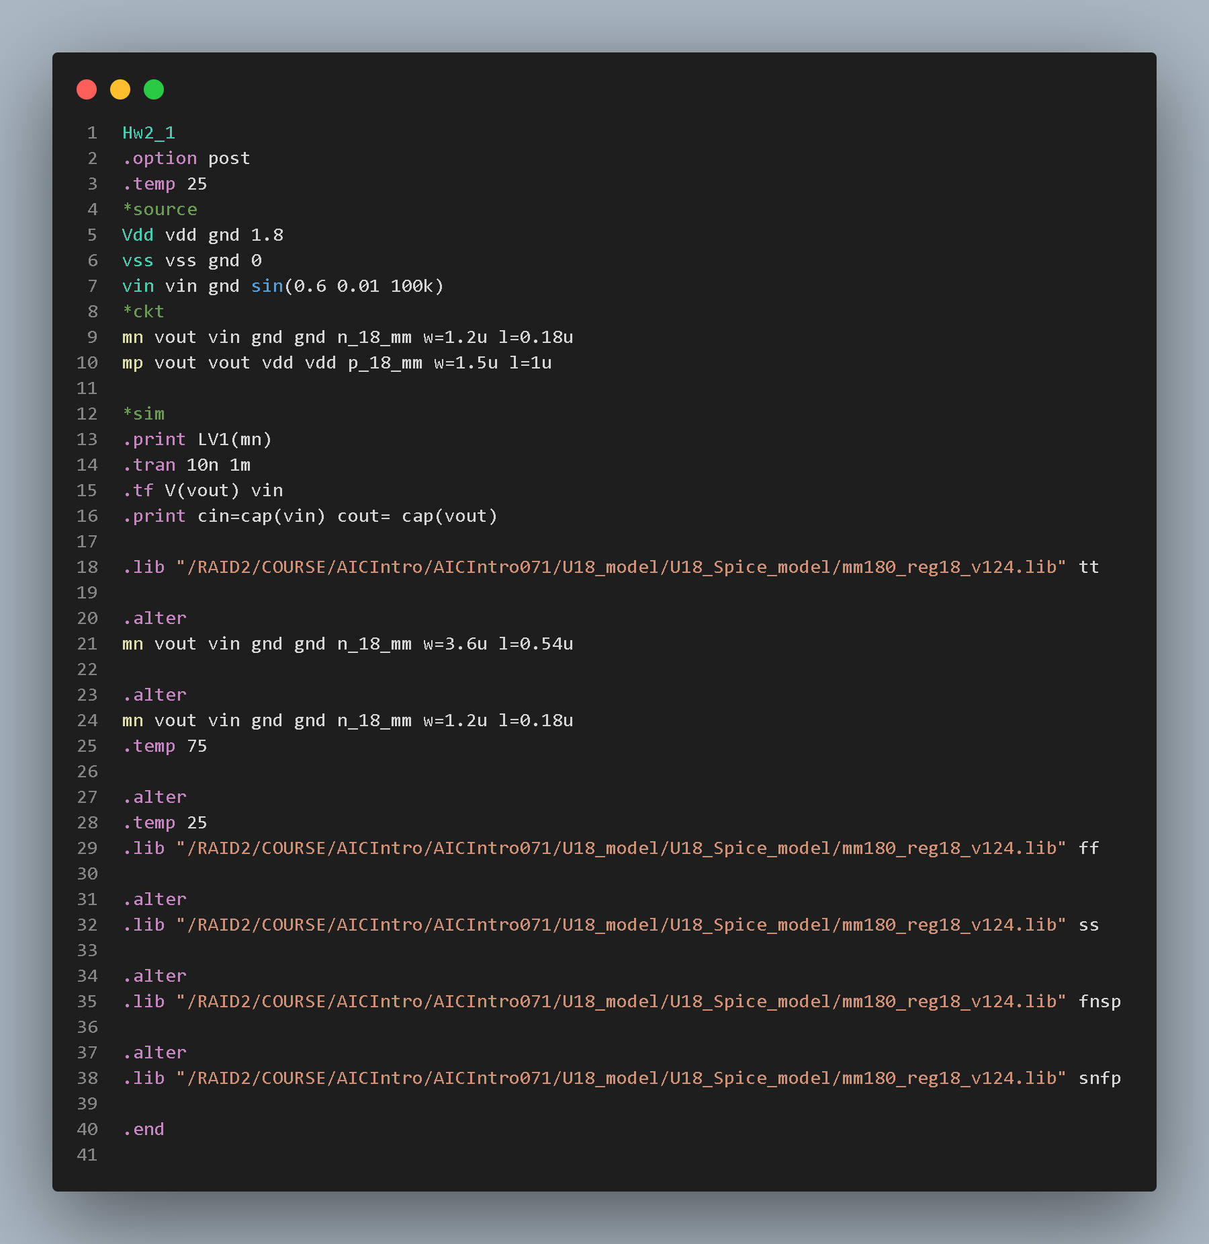

**The pictures below are all in the order as the chart.**

**Vout waveform:**

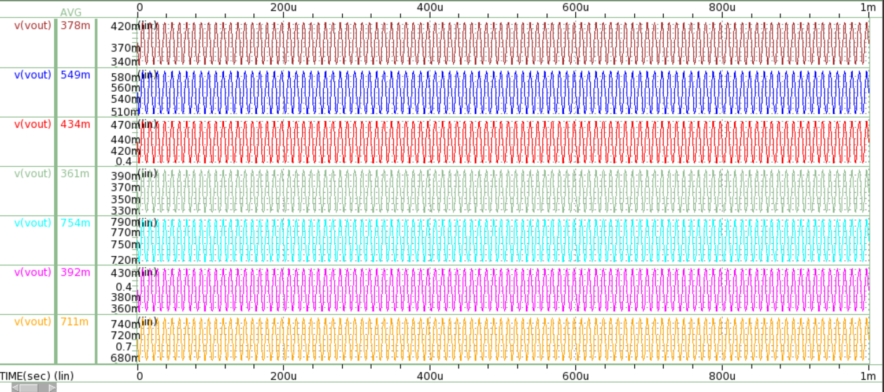

**Ids waveform:**

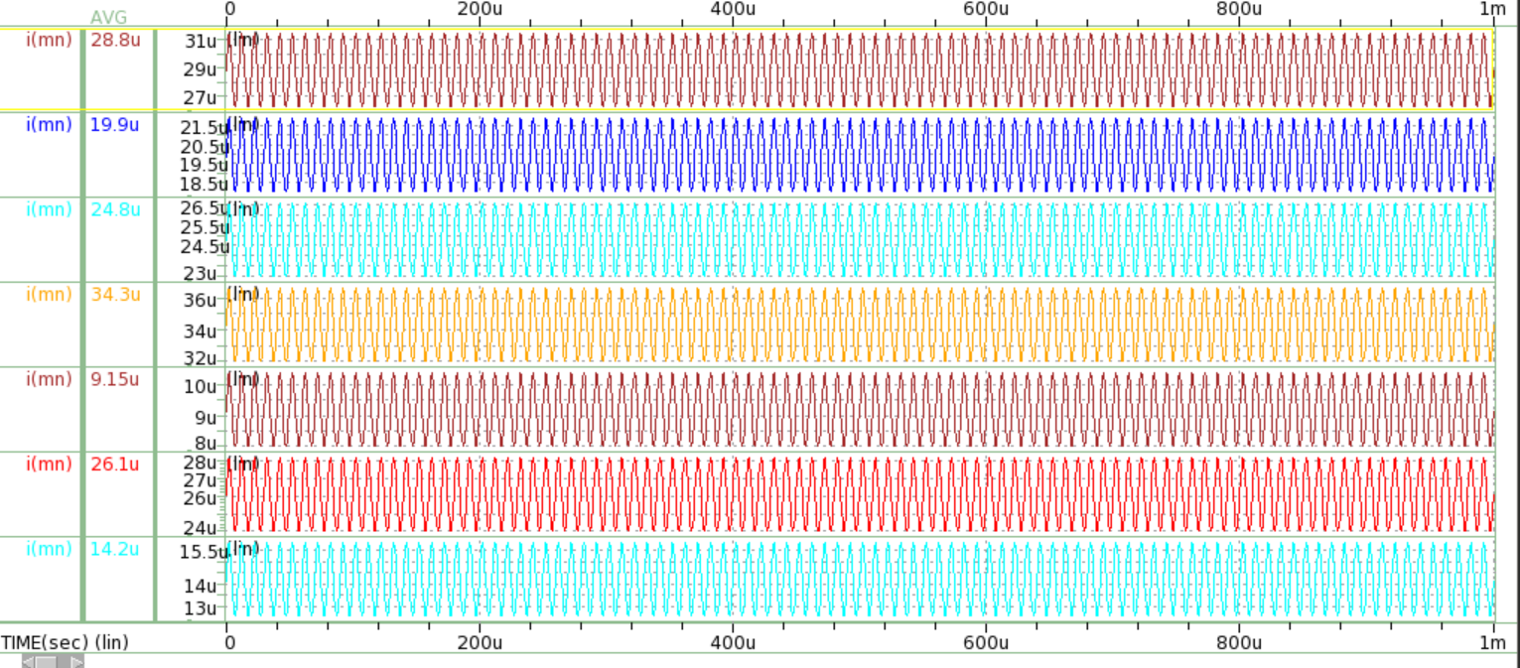

**Small signal:**

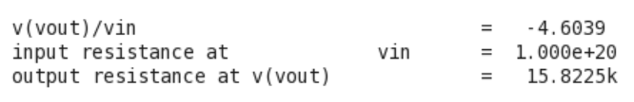

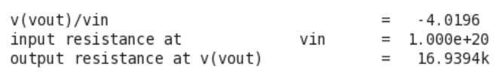

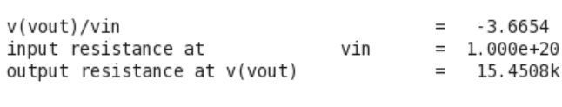

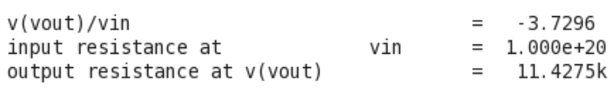

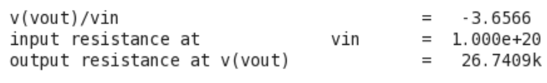

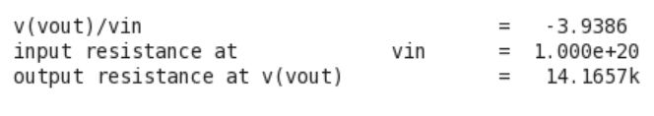

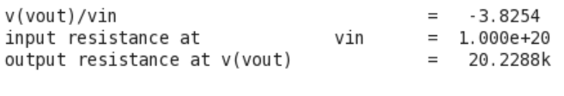

**Cin:**

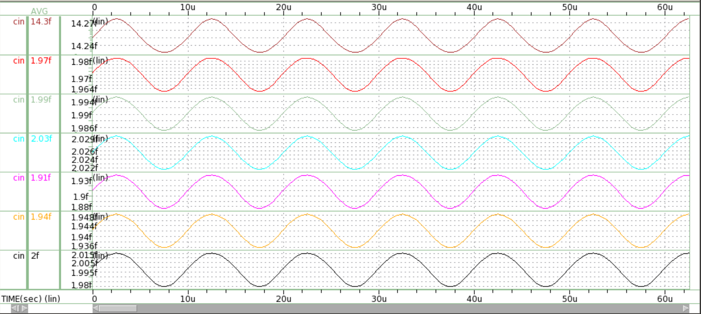

**Cout:**

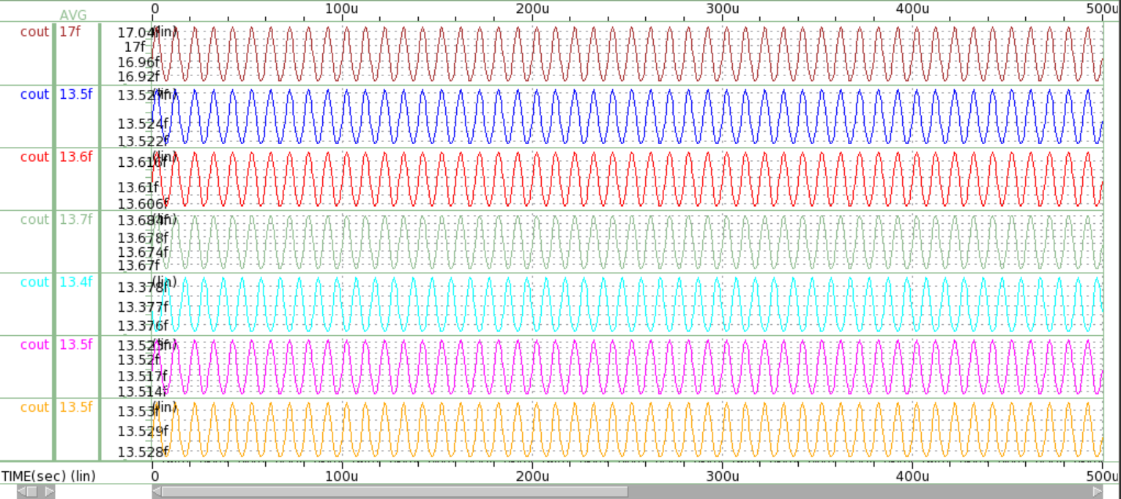

Table: NMOS common-source amplifier

|  |  |  |  |  |  |  |  |  |
| --- | --- | --- | --- | --- | --- | --- | --- | --- |
| **Corner** | **Temp**  **(°C)** | **Circuit** | **Vout**  **(V)** | **Ids**  **(mA)** | **DC gain**  **(V/V)** | **Rout**  **(Ω)** | **Cin**  **(F)** | **Cout**  **(F)** |
| TT | 25 | Fig. 2 | 378m | 0.0288 | -4.604 | 15.823k | 14.3f | 17f |
| TT | 25 | Fig. 1 | 549m | 0.0199 | -4.019 | 16.939k | 1.97f | 13.5f |
| TT | 75 | Fig. 1 | 434m | 0.0248 | -3.665 | 15.451k | 1.99f | 13.6f |
| FF | 25 | Fig. 1 | 361m | 0.0343 | -3.73 | 11.428k | 2.03f | 13.7f |
| SS | 25 | Fig. 1 | 754m | 0.00915 | -3.657 | 26.741k | 1.91f | 13.4f |
| FnSp | 25 | Fig. 1 | 392m | 0.0261 | -3.939 | 14.166k | 1.94f | 13.5f |
| SnFp | 25 | Fig. 1 | 711m | 0.0142 | -3.825 | 20.229k | 2f | 13.5f |

**Hw2.2**

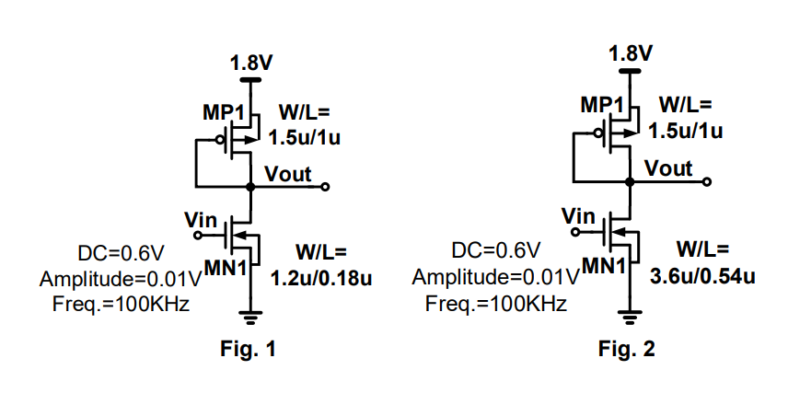

**Figure 1.W/L=1.2u/0.18u=6.6667**

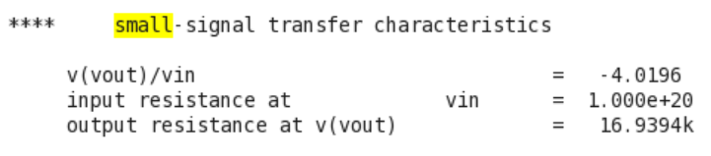

**Figure 2.W/L=3.6u/0.54u=6.6667**

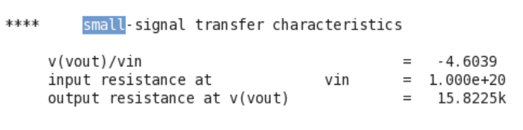

**The picture above shows the output resistance of Figure1 is larger than Figure2. Some reasons determine this result. First, the Rout of both circuits is equal to $\frac{1}{gmp}$//rop//ron.**

**And we know gmp is proportional to ID. Due to the velocity saturation on short channel devices, ID will prematurely saturate, which causes ID much smaller than expected. Thus, the smaller gmp and ID are, the larger the Rout will be.**

**Also, the ron is equal to $\frac{1}{ λID}$. Thus, As ID decreases, ron will also get larger. What’s more, λ is proportional to $\frac{1}{L}$, which will cause a larger Rout when Length is small.**

HSPICE_HW2：作業需要有以下幾點：

* + 1. HSPICE Code (截圖)
    2. Simulation Result (波形繳交背景請用白色，並且波形標示和呈現要清楚)
    3. 每個小題的單獨說明**問題(1)** 填表格

**問題(2)** 說明

**問題(3)** 說明

* + 1. 以.pdf 的格式上傳
    2. 檔案名稱用「Hspice_HW2_自己的學號」(例如：Hspice_HW2_0811541)，於作業繳交截止日期前，上傳到指定的 E3 數位平台繳交